**Valve Controller USER MANUAL**

# Board image

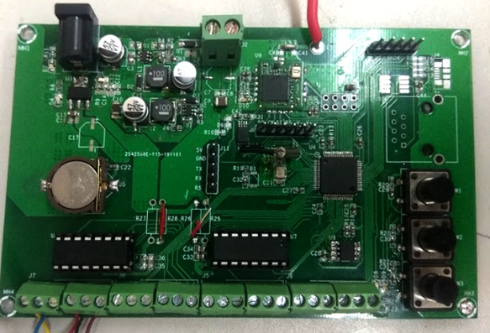

Figure 1 Board Image

# Board layout (top view)

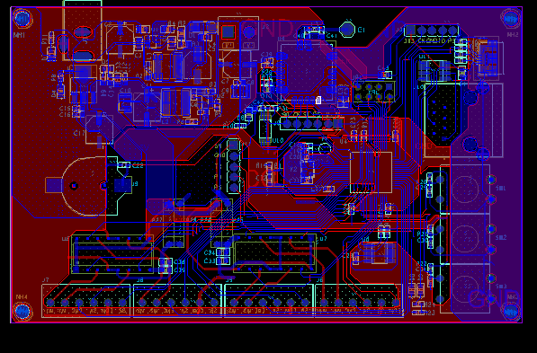

Figure 2 Board Layout

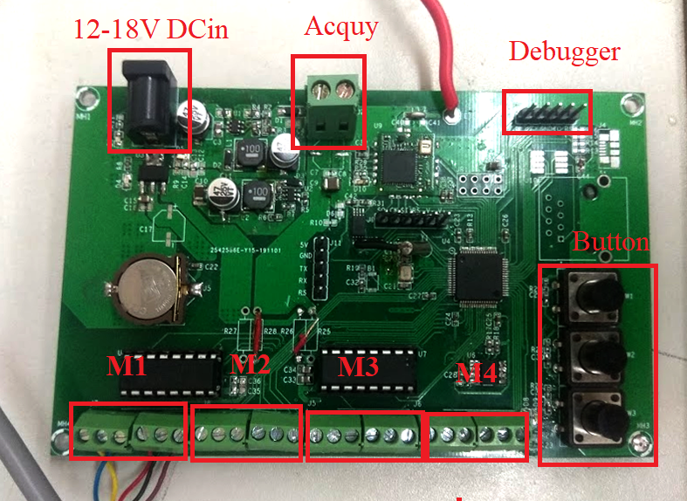

Figure 3 Board Description

# Valve IO:

* From left to right on ***Figure 3***,: M1 M2 M3 M4are motor ports.
* Each motor port has six pins: M+, M-, ENC – Encoder, SA – Sensor A, GND, SB – Sensor B.
* This board supports two types of motors:
  + M1, M2: Support full control valve (blue valve), including direction control and stop –sensor feedback. This type needs five pins to operate.
  + 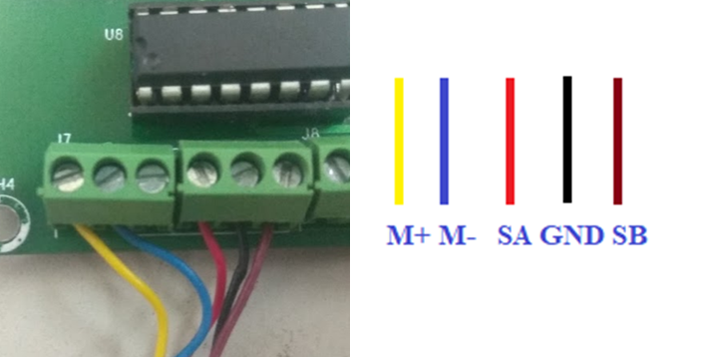
  + M3, M4: Support orange valve. Only need 2 pins: M+ M-

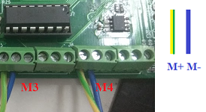

# Power supply:

* Support 16V-DC input and 12V Battery.

# Button:

* The Valve Controller has three button
  + BTN1: for Z-wave communication.
  + BTN2: Long press to open all valve.
  + BTN3: Long press to close all valve.

# Z-wave communication:

* This board supports Z-wave as a node.
* To enter Include/Exclude mode, long press SW1 until LED D9 blink.
* To reset Z-wave, long press SW1 until LED D9 blink and waiting for D9 blink slower.
* After connected, the valves can be control over Z-wave PC Controller program.

# How to use Z- wave PC Controller

* After Z-wave Controller (Z-Stick) is connected to computer, open Z-Wave PC Controller.

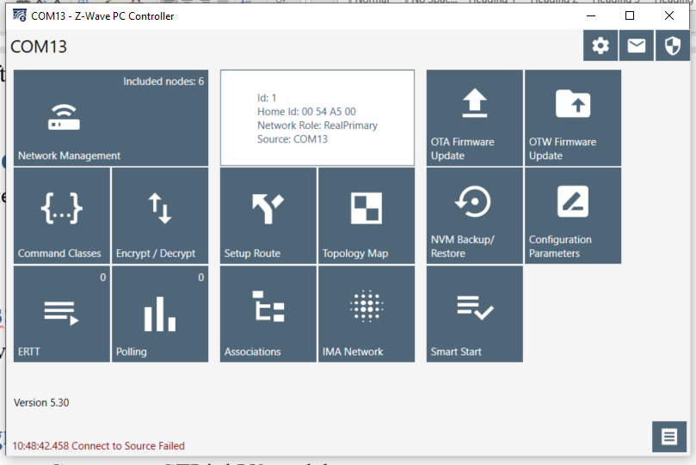

Figure 4 Zwave PC Controller UI

* Go to Network Management, click Add. Controller will wait for the node information, long press SW1 until LED D9 on the Valve Controller Board blink 🡪 The valve starts to be included into the network.
* 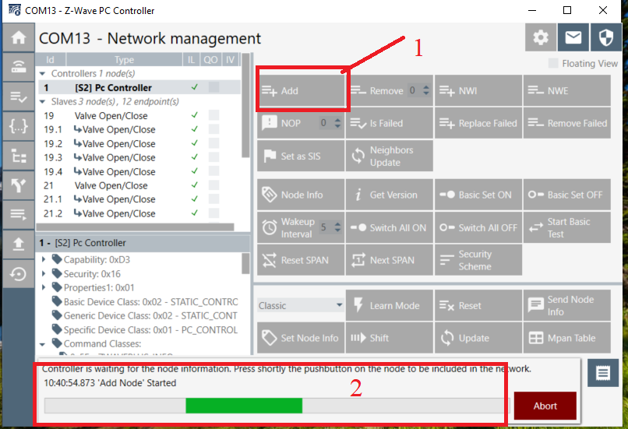

Figure 5 Add node to PC Controller

* If the inclusion completed, the program will show somethings as below:

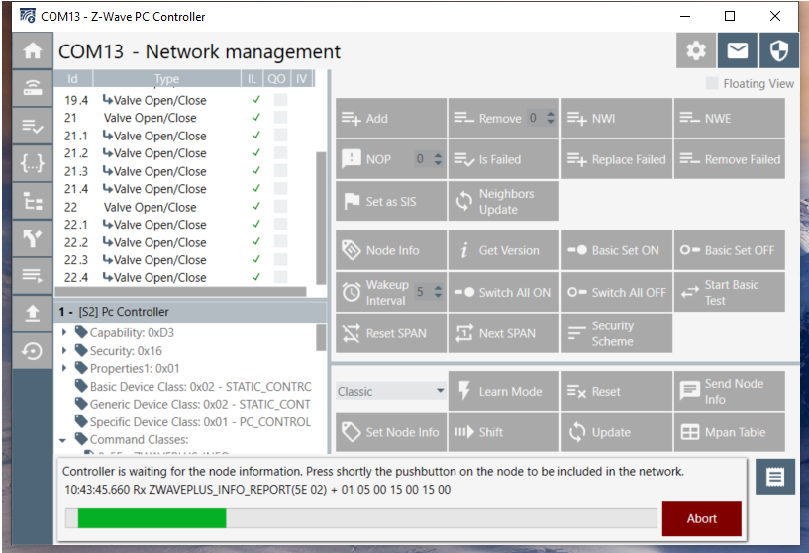

Figure 6 Add node complete

* To control the valve, select valve ID -> select SWITCH_BINARY -> Select SWITCH_BINARY_SET -> Select Valve Sate (ON/OFF) -> Send command. 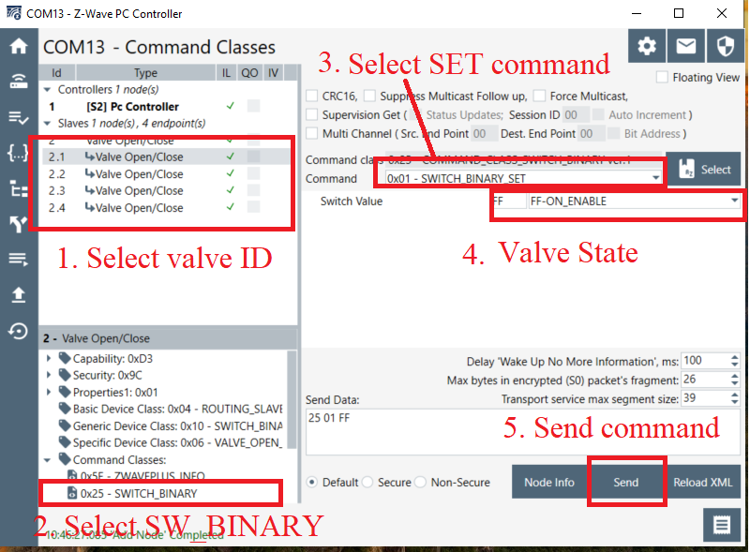

Figure 7 Control the valves using PC Controller

* You can see log by clicking Show Log.

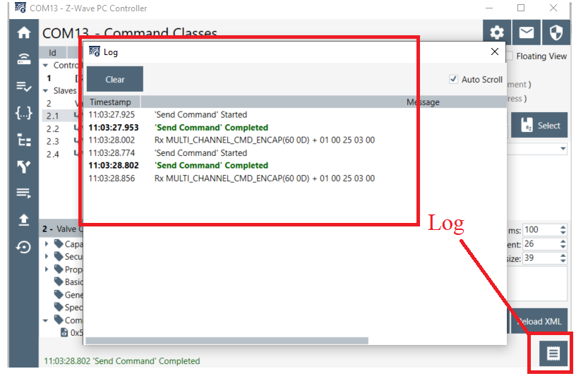

Figure 8 Logger

s

# Leds:

* LED will indicate button processes.

# Programming port: Figure 6

* Connect to STLinkV2 to debugger.

Figure 9: Board running

# Wi-fi Communication:

# Schedule

# GSM Communication

# RS485 Communication